BUDT 703 Fall 2021 Homework #4 – SQL DML

Due by 11:59pm, Monday, October 25th, 2021

**Note**: The file name must be renamed to **HW4_YourLastName_YourFirstName.docx**.

Follow the following steps to answer user queries for the **Terps Enterprise, Inc.** database.

1. Download file **HW 4 – Enterprise.sql** (not what you submitted for Homework #3)
2. Execute DROP TABLE, CREATE TABLE, INSERT INTO, and ALTER TABLE statements to create six tables inserted with corresponding data.
3. Compose SQL SELECT FROM statements to answer user queries below.
4. Take screenshots on the result tables of up to the first eight rows with the status bar showing total number of rows on the lower-right corner. Do NOT attach the entire result table containing more than eight rows.
5. Copy and paste each of your SQL SELECT FROM statements (in plain text) and screenshots to the corresponding question below, and submit only this document.

# SQL queries:

* + - 1. What are the full details of all employees in the alphabetical order of last then first names within every department?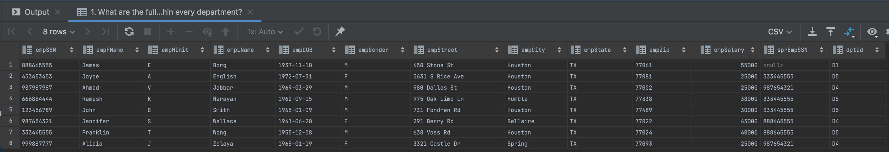
      2. How many unique department locations?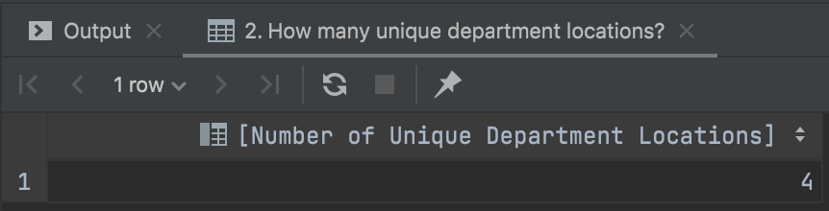
      3. What are the managers' names and the corresponding department names, in the alphabetical order of last then first names?

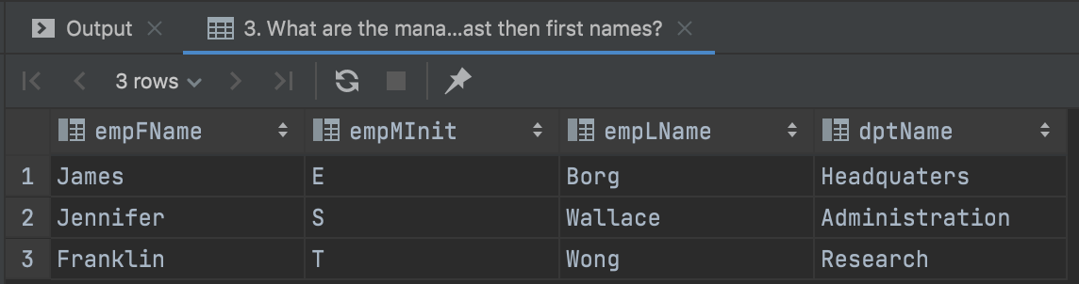

* + - 1. For each department name, how many employees in the department, in the order of department names?

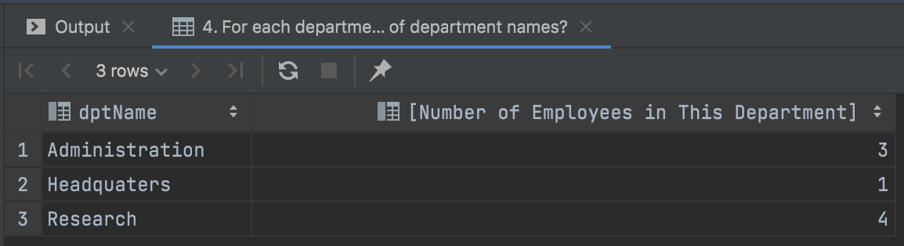

* + - 1. For each department name, how many locations in the department, in the order of department names?

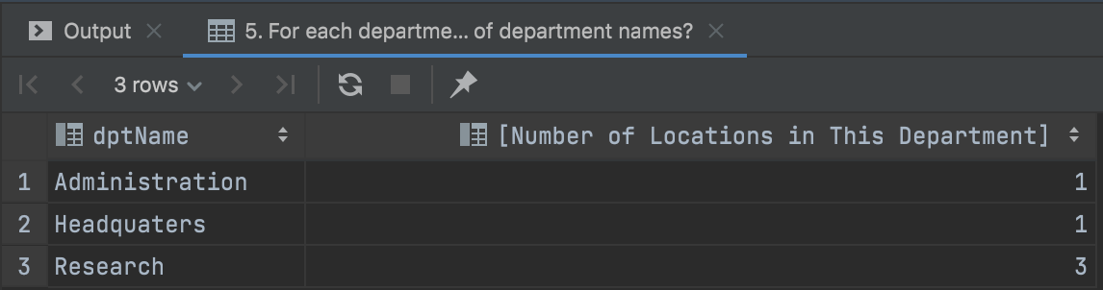

* + - 1. What are employee names, in the alphabetical order of their last then first names, who work on projects organized by the research department?

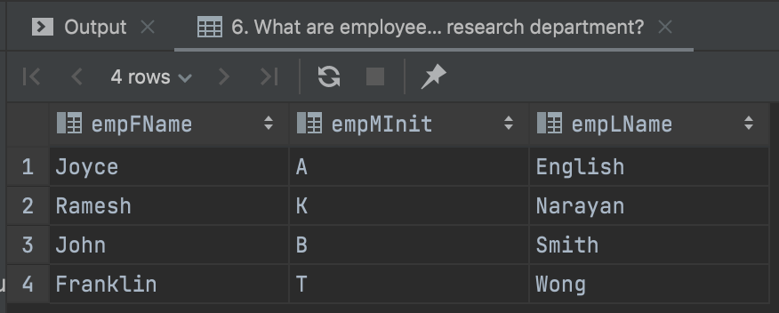

* + - 1. What are employee names, in the alphabetical order of their last then first names, and numbers of worked projects, where the employee worked on at least two projects?

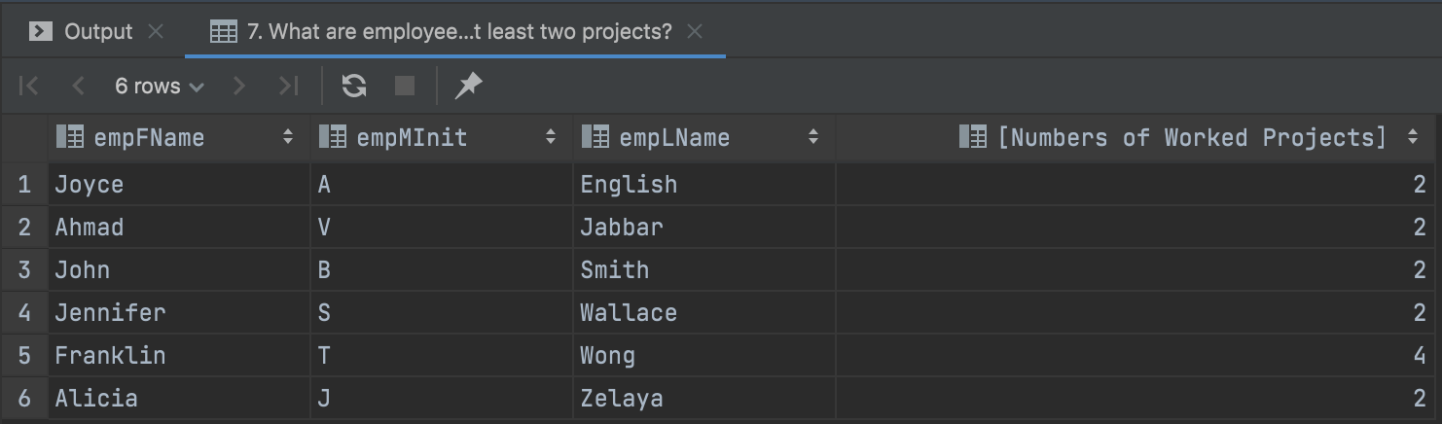

* + - 1. What are all details of a department, which organizes more than one project?

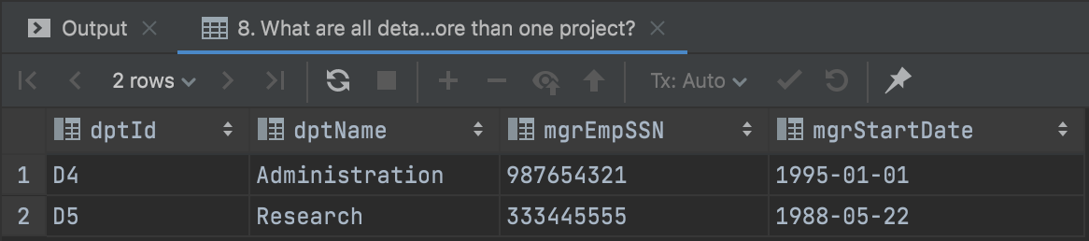

* + - 1. What are all details of managers in the departments, for which more than three employees work in?



* + - 1. What are all details about the oldest employee?



* + - 1. What are all details about employees, who have letter 'e' in the name?

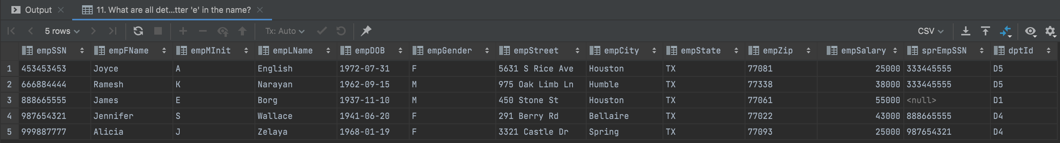

* + - 1. What are all details of a dependent, who has the same gender as the corresponding employee, using correlated subquery?

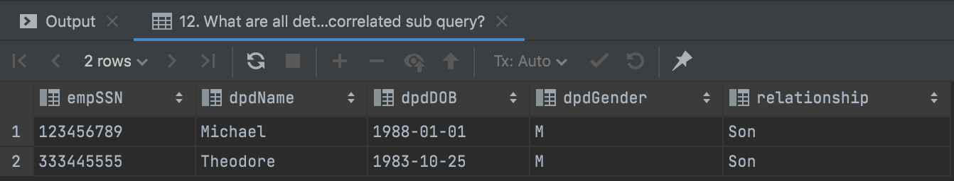

* + - 1. What are the cities, where there is either a department or a project?

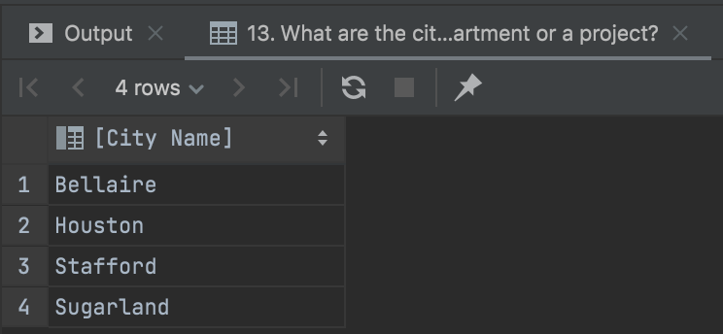

* + - 1. What are the cities, where there is both department and project?

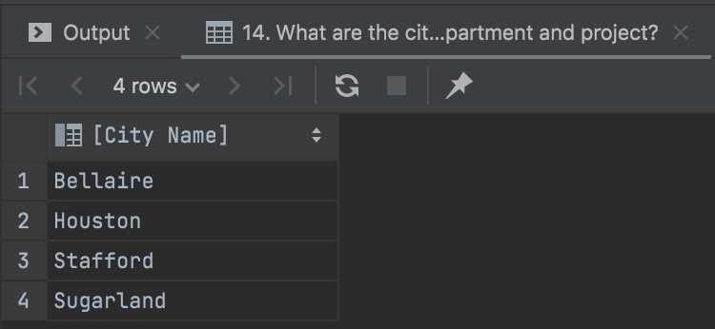

* + - 1. What are the numbers of work hours for all possible combinations of employees and then projects? (Hints: This is an OLAP query using GROUP BY CUBE. Work hours canNOT be NULL. The results should be sorted by the employee SSNs then the project ids.)